Spring Data JPA Relationships

Why Spring Data JPA Relationships Matter in Real Projects ?
In real-world backend systems, data never exists in isolation.
Almost every production system involves:
- Parent–child data
- Ownership relationships
- Aggregates
- Referential integrity
- Transactional consistency across tables
Spring Data JPA relationships are not about annotations alone.
They directly affect:
- SQL schema design
- Foreign key constraints
- Transaction behavior
- Insert/update/delete order
- Performance (joins, fetching, cascades)
- Serialization (JSON recursion issues)
- Data integrity bugs in production
A wrong relationship design can cause:
- Data inconsistency
- Infinite JSON loops
- N+1 query issues
- Orphan records
- Unexpected deletes
What Is a Relationship Between Entities?
In JPA, a relationship defines how one entity references another entity and how that mapping translates to database foreign keys and joins.
At database level:
- One table holds a foreign key
- That foreign key references a primary key in another table
At JPA level:
- One entity holds a Java object reference
- JPA maps that object reference to a foreign key column
Key principle
👉 Relationships are defined in entities, not in controllers or services.

Types of Relationships in JPA
Spring Data JPA supports four core relationship types:
- OneToOne
- OneToMany
- ManyToOne
- ManyToMany
Each has:
- A database meaning
- An owning side
- A non-owning (mappedBy) side
- Cascade and fetch implications

One-to-One Relationship – Deep Dive (AMS Scenario)
Scenario: Application Management System (AMS)
- Applicant → can upload only one Resume
- Resume → belongs to only one Applicant
This is a strict one-to-one relationship.
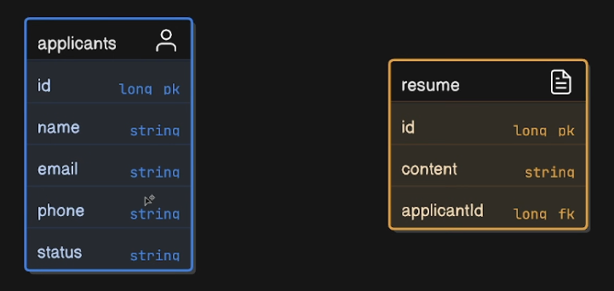
Database View
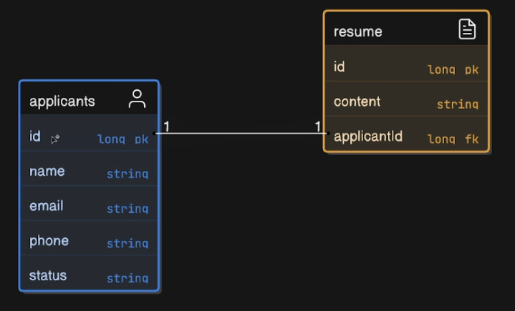

Entity Relationship (ER) Concept
- Resume holds the foreign key
- Resume is the owning side
- Applicant is the inverse side
OneToOne – Entity Implementation (Unidirectional)
Applicant Entity
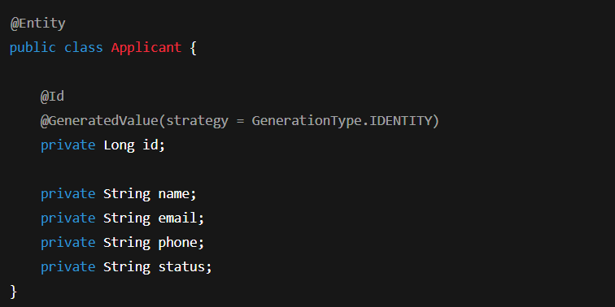
Resume Entity (Owning Side)
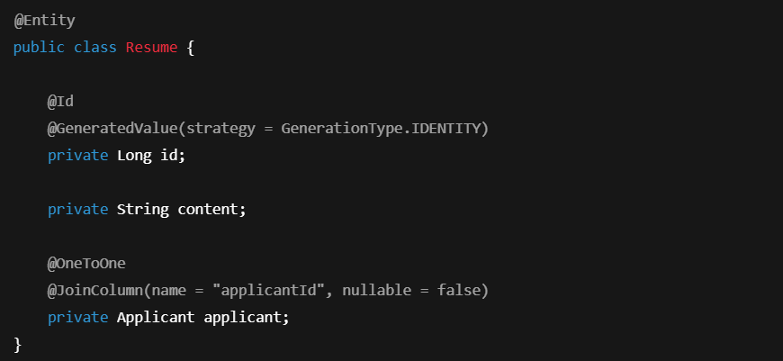What Actually Happens Internally unidirectional mapping
- @JoinColumn creates applicantId column
- JPA enforces foreign key relationship
- Resume table holds the FK → Applicant table
- Applicant entity is not aware of Resume
Resume API Flow (Unidirectional)
ResumeController
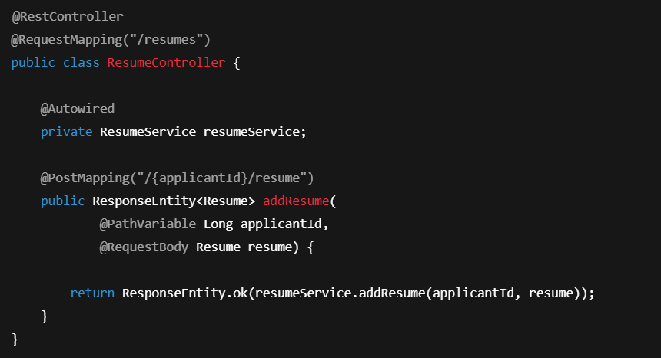
ResumeService
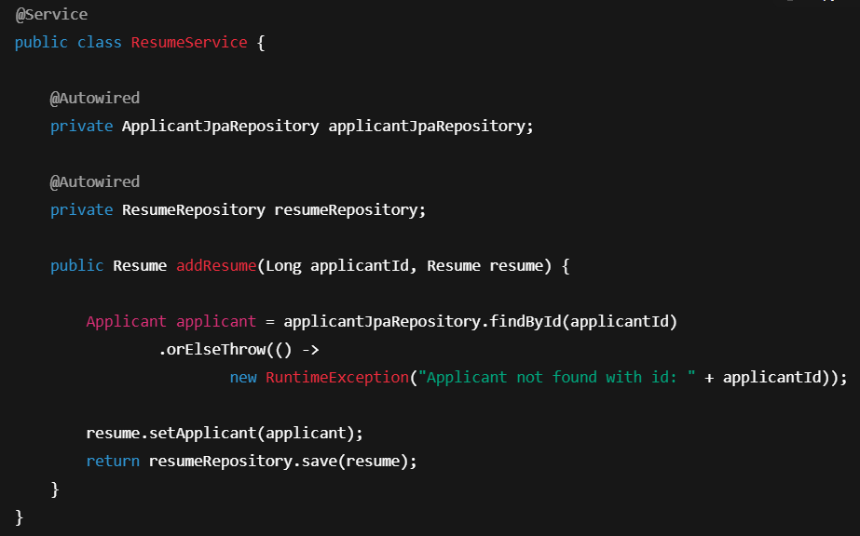
ResumeRepository
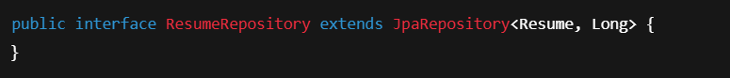

Bidirectional OneToOne Mapping
Now we want:
- Resume ↔ Applicant (both directions)
Applicant Entity (Inverse Side)
 Now:
- Resume owns the relationship
- Applicant is the inverse side
Problem: Insert Order Issue
If you try to save Applicant with Resume directly, JPA throws an error because:
- Resume needs applicantId
- Applicant is not saved yet
- applicantId does not exist

Solution 1: Manual Save Order
In ApplicantService:
- Save Applicant
- Set Applicant in Resume
- Save Resume
This works but is error-prone and repetitive.
Solution 2: Cascading (Correct Approach)
Add Cascade

What CascadeType.ALL Means
- PERSIST → save child when parent saved
- MERGE → update child automatically
- REMOVE → delete child when parent deleted
- REFRESH, DETACH
Cascade controls entity lifecycle propagation

New Problem: Circular JSON Serialization
Now API returns:
- Applicant → Resume → Applicant → Resume → ∞

Fix: @JsonIgnore
Resume Entity
 Why This Works
- Jackson ignores applicant field during serialization
- Breaks infinite recursion
- Does not affect database relationship
@JsonIgnore is a serialization-level fix, not a JPA fix.
OneToMany & ManyToOne Relationship
Scenario: Applicant → Applications
- One Applicant → Many Applications
- Many Applications → One Applicant
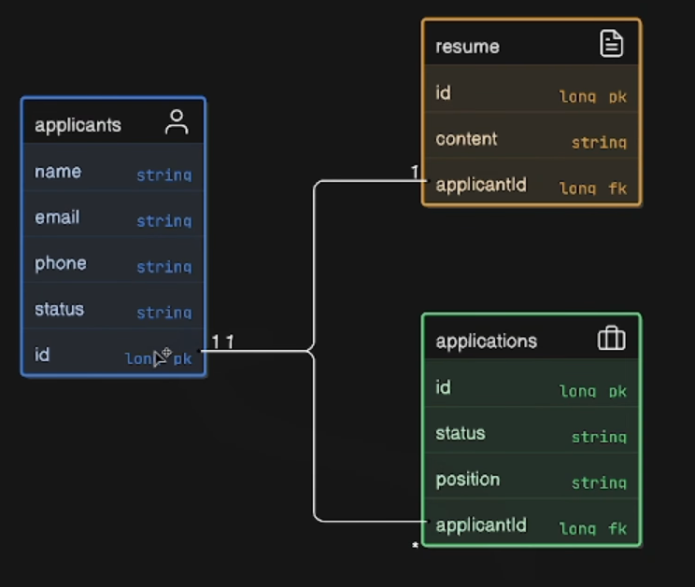
Application Entity (Owning Side)
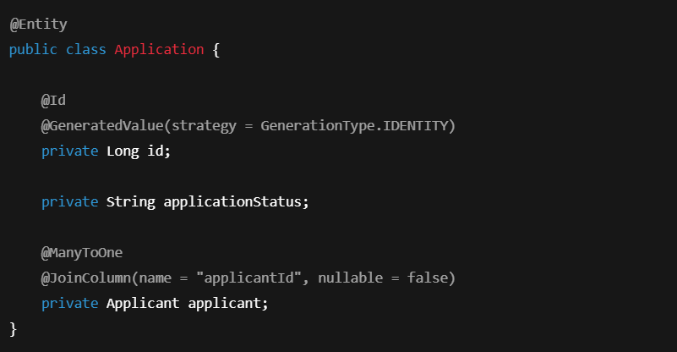
Applicant Entity

Key Concept
- @ManyToOne is always the owning side
- Foreign key exists in many-side table
- OneToMany is almost always mappedBy

ManyToMany Relationship – Job Scenario
Scenario
- One Applicant → Many Jobs
- One Job → Many Applicants
This creates a join table.
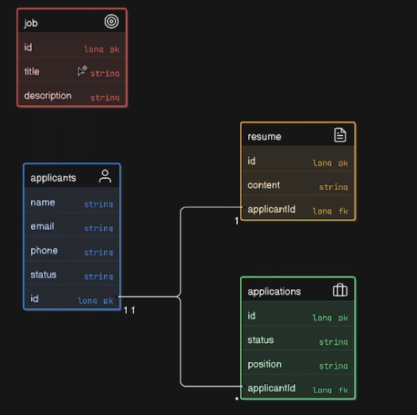
Applicant Entity
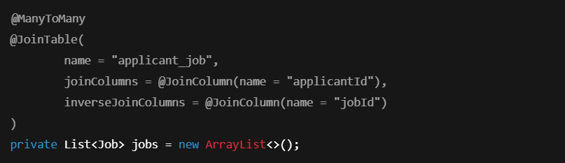
Job Entity

Database Result
applicant_job
- applicantId
- jobId
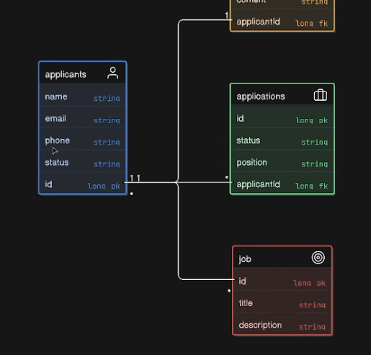
Spring Data JPA Relationships – Scenario-Wise Quick Summary

One-to-One Relationship
Scenario: Applicant ↔ Resume
Meaning
- One Applicant → One Resume
- Resume holds the foreign key (applicantId)
Owning Side
- Resume entity
Annotations Used
- @OneToOne
- @JoinColumn(name = "applicantId")
- mappedBy (in Applicant)
- CascadeType.ALL
- @JsonIgnore
Key Points
- Foreign key exists in Resume table
- mappedBy avoids duplicate FK
- Cascade handles save/delete order
- @JsonIgnore prevents infinite JSON loop

One-to-Many / Many-to-One Relationship
Scenario: Applicant → Applications
Meaning
- One Applicant → Many Applications
- Many Applications → One Applicant
Owning Side
- @ManyToOne (Application entity)
Annotations Used
- @ManyToOne
- @JoinColumn(name = "applicantId")
- @OneToMany(mappedBy = "applicant")
- CascadeType.ALL
Key Points
- Foreign key always on many-side
- @ManyToOne controls DB updates
- @OneToMany is inverse side
- Parent must be set in child before save

Many-to-Many Relationship
Scenario: Applicant ↔ Job
Meaning
- One Applicant → Many Jobs
- One Job → Many Applicants


Database
- Join table (applicant_job)
Annotations Used
- @ManyToMany
- @JoinTable
- mappedBy
Key Points
- Join table holds both FKs
- Avoid in large systems
- Prefer join entity for scalability

Cascade – Must Know
Purpose
- Controls entity lifecycle propagation
Common Usage
- CascadeType.ALL → Save/Delete child with parent
Important
- Cascade ≠ Relationship
- Cascade ≠ Join

Serialization Handling
Problem
- Bidirectional mapping causes infinite loop
Solution
- @JsonIgnore on back reference

Note
- Affects JSON only, not DB behavior

Must-Remember Rules
- Owning side controls foreign key
- mappedBy = inverse side
- Many-side usually owns relationship
- Cascade manages lifecycle, not joins
- Always control JSON serialization

